**IKEMKA ROMASON ROMANUS**

**BHU/20/04/05/0016**

**CMP 408 CRYPTOGRAPHY LAB**

The enc command in OpenSSL is used for encryption and decryption using various cipher algorithms.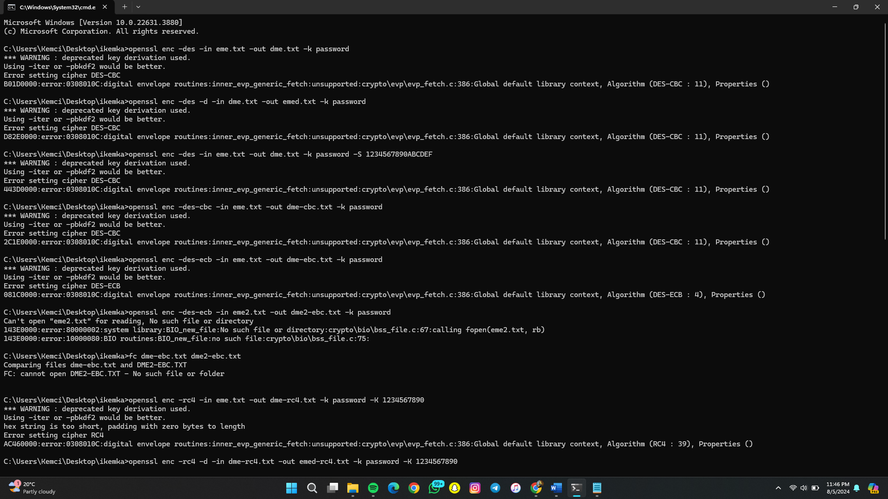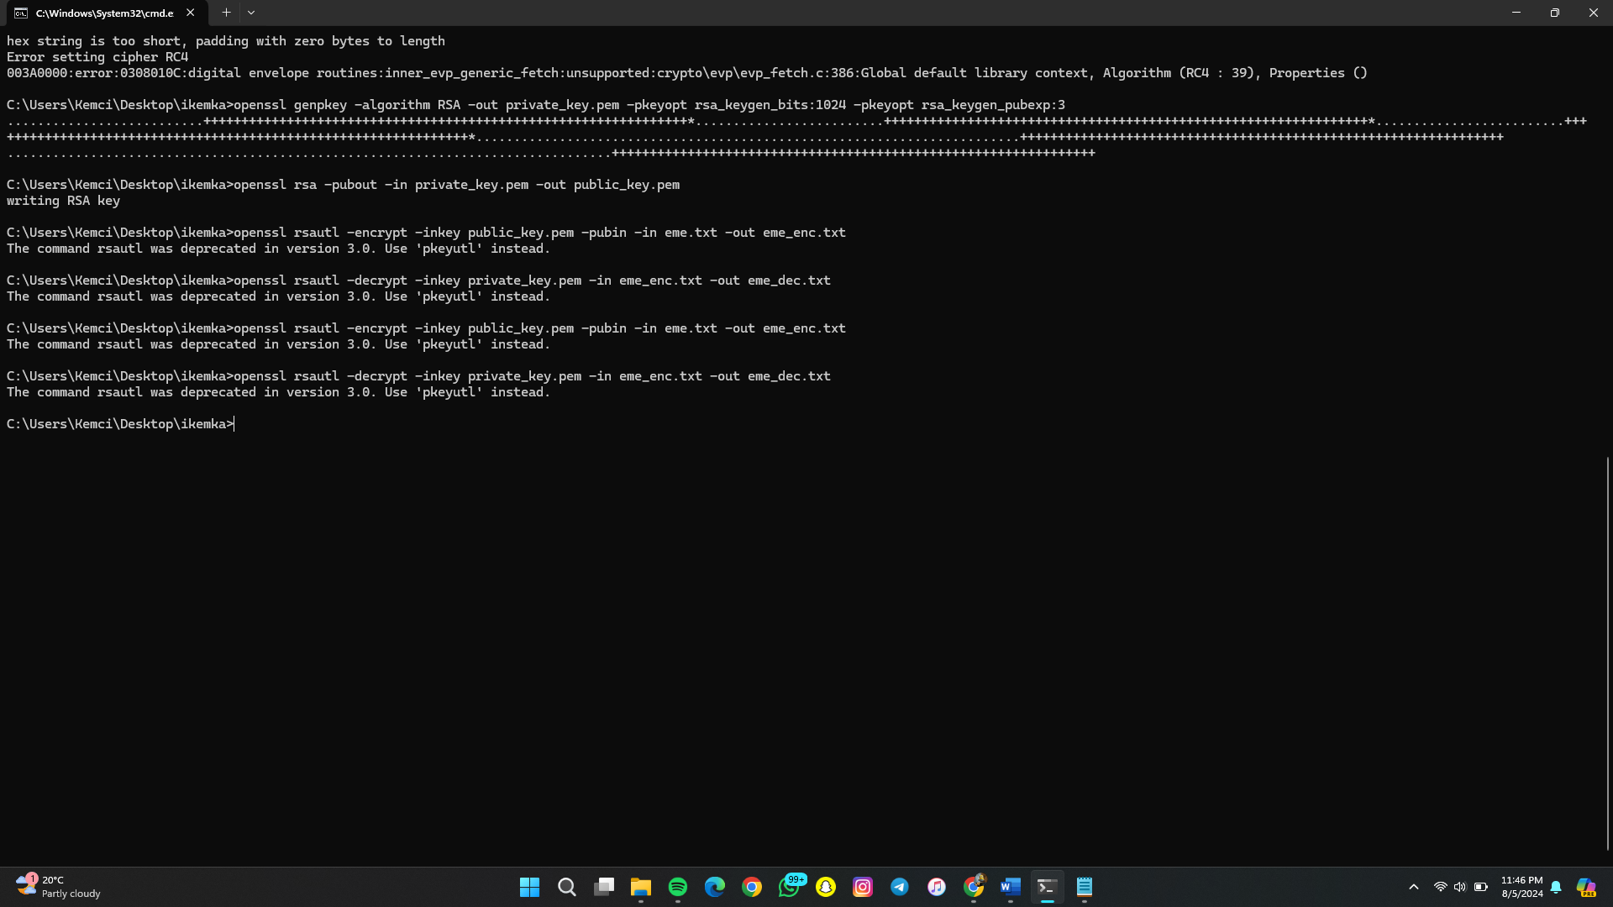

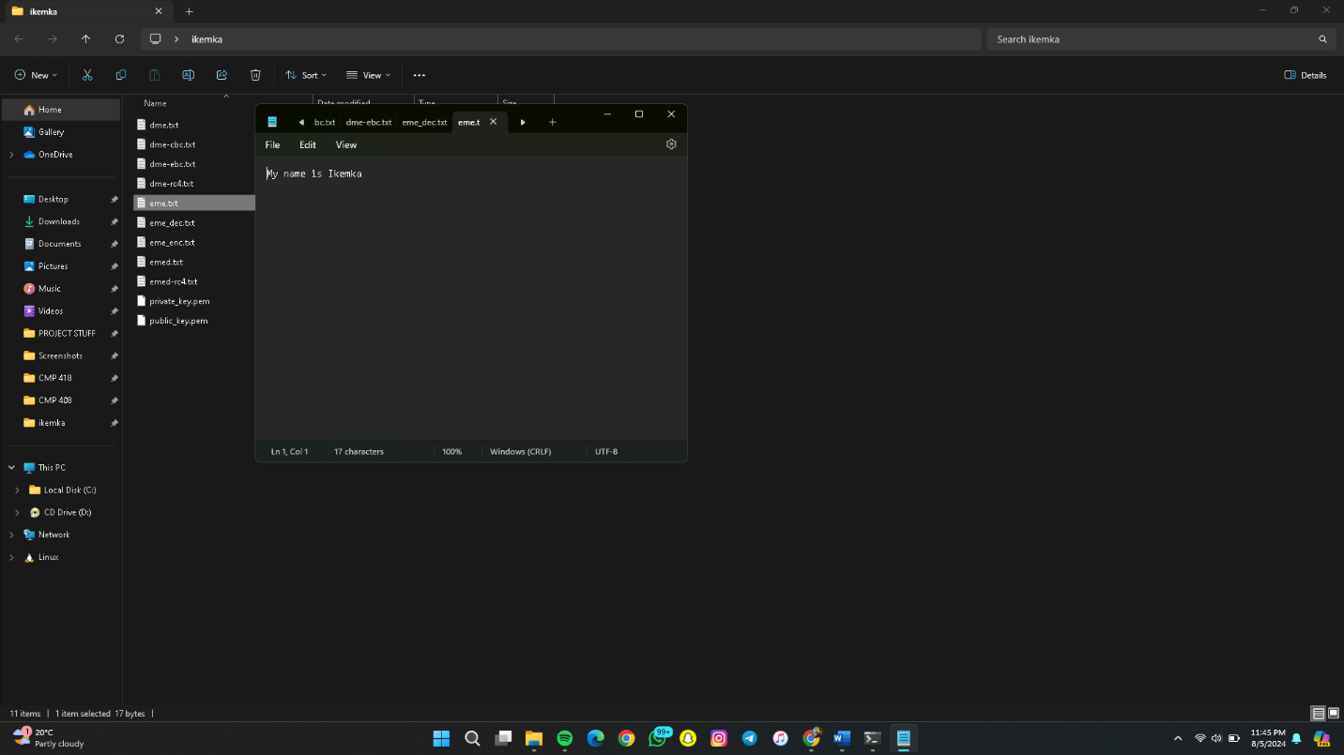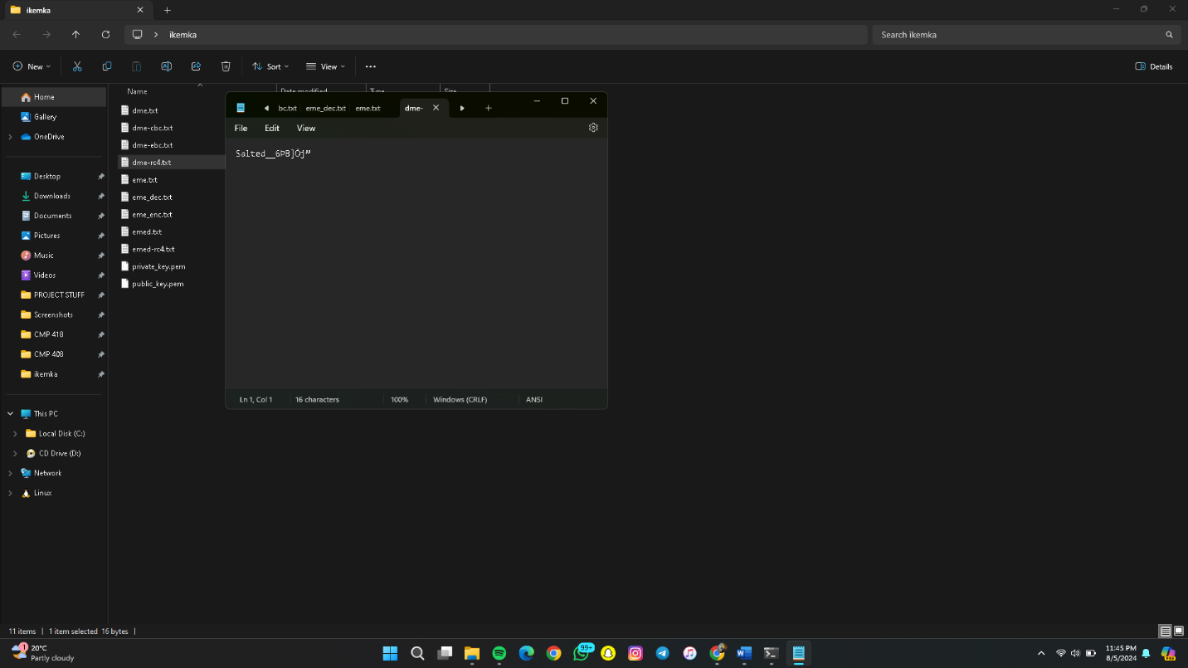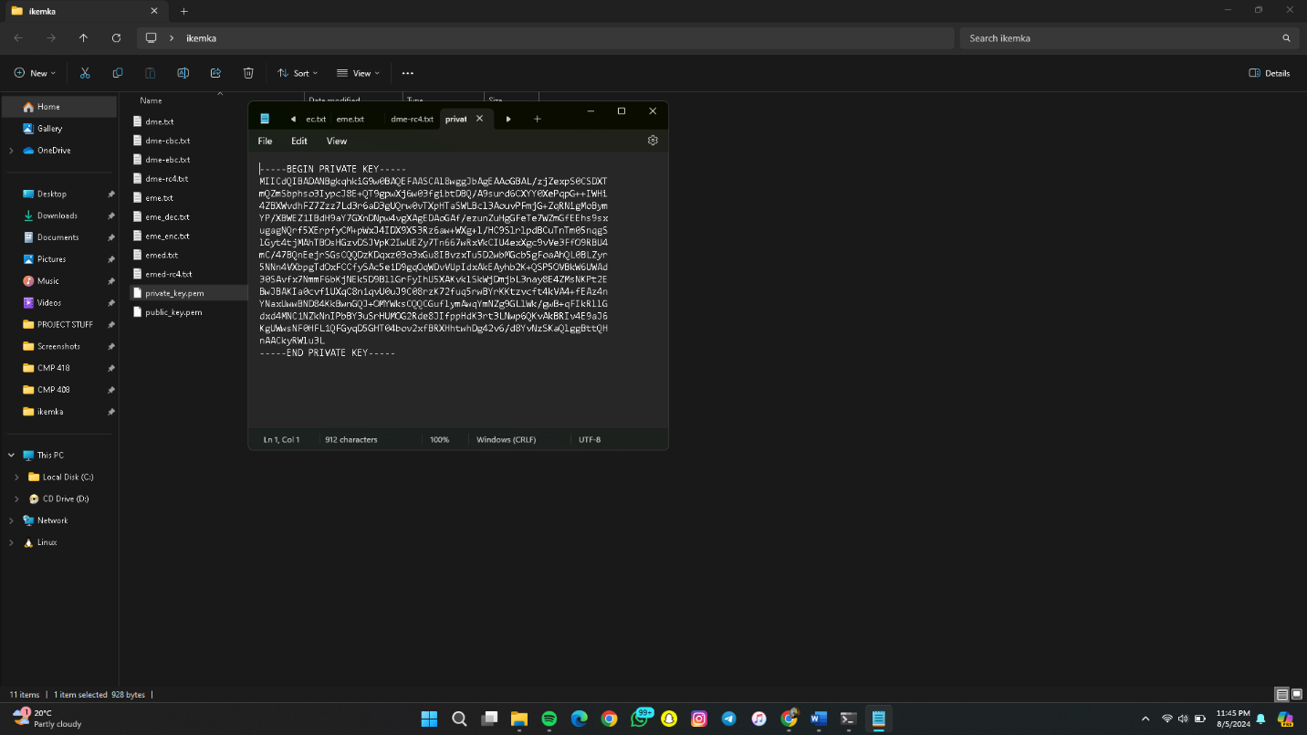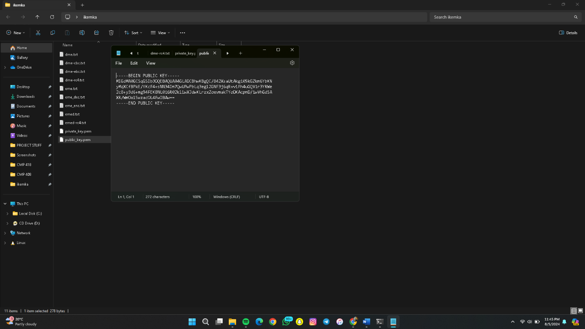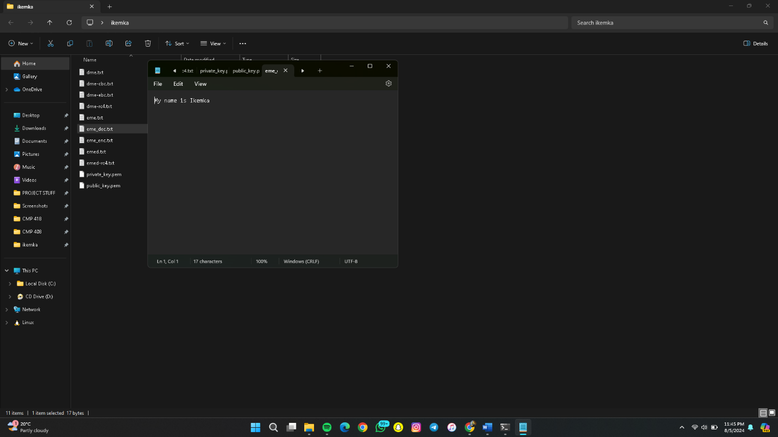

Part 5

• **CSR Format:**

* CSR (Certificate Signing Request) is a block of encoded text containing information about the applicant of a certificate.

• **ASN.1 Format:**

* ASN.1 (Abstract Syntax Notation One) is a standard interface description language for defining data structures used in cryptography.

• **DER Format:**

* DER (Distinguished Encoding Rules) is a binary encoding for X.509 certificates and other data structures described by ASN.1.

• **Create a Self-Signed X.509 Certificate:**

openssl req -new -x509 -key private_key.pem -out self_signed_cert.pem -days 365